Objective
The objective of this study is to determine a simple method of accurately distributing the self-weight dead load of traffic barriers, sidewalks, combination railings, and median barriers to the superstructure systems typically used in WSDOT bridges and propose changes to the BDM to reflect the recommendations of this study.

Current Practice
The current practice is to the divide traffic barrier dead load equally to a maximum of three girders (see BDM Section 5.6.2-B.d). When a bridge has 5 or fewer girders, the dead load of both traffic barriers is distributed evenly to all girders. This design guidance can be construed to apply only to precast-prestressed girder bridges as it is defined in section 5 of the BDM. Specific guidance is not given for sidewalks, combination railings, and median barriers or other superstructure types (e.g. steel I or U girders).

Inconsistency in Distribution of Traffic Barrier Loads
Section 5.6.2-B.2.d of the BDM states that the traffic barrier dead load is to be divided among a maximum of three girders. This leads to an inconsistency in the loading for the two bridge sections shown below. These two sections are identical with respect to the number of support locations for the deck slab.

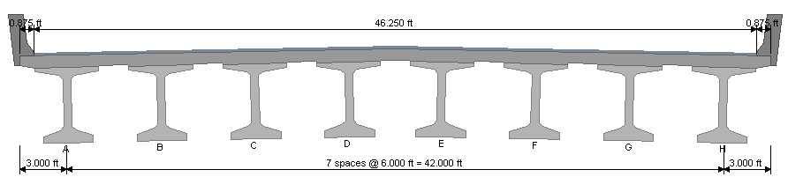
Case 1 – 8 WF girders
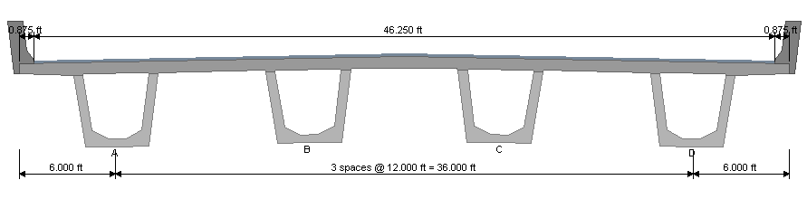
Case 2 – 4 U girders

In case 1, the three exterior girders would carry one-third of the traffic barrier weight. In case 2, all four girders would equally share the weight of two traffic barriers. In case 1, the weight of the barrier is distributed transversely over 27 feet, however, in case 2 the same load is distributed over 48 feet.

Factors to Consider
The factors to consider include:
- Type of superstructure (Precast I-beams, Steel I-Beams, Precast U-beams, Steel U-beams, voided slabs, solid slabs, deck bulb tee, etc).
- Superstructure Depth (for precast I-beams include both the most shallow (WF36G) and deepest girders (WF100G))
- Thickness of deck (typically 7.5”)
- Deck material (typically 4 KSI)
- Girder spacing (typically 5ft – 14ft)
- Deck overhang (typically 3ft – 8ft)
- Location of barrier/railing (exterior, combination, median)
- Width of sidewalk (typically 4ft – 12ft)

Should the dead load be distributed to the 3 exterior girders for wide girder spacing?
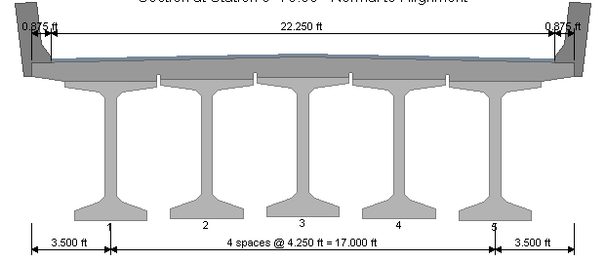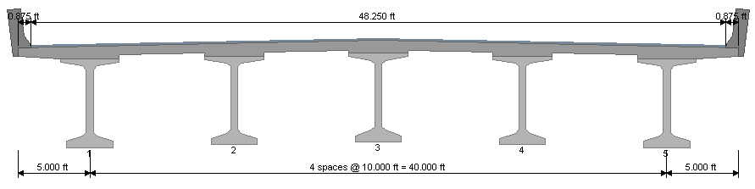

Does the interior barrier distribute to the same 3 girders as an exterior barrier?
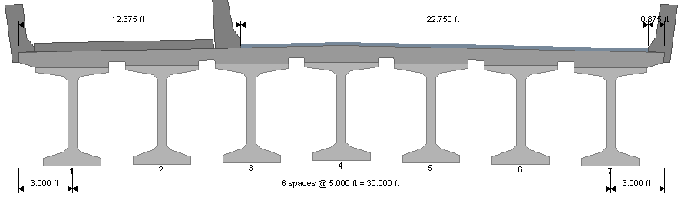
Is the distribution the same for voided slabs as it is for I-beams and tubs?
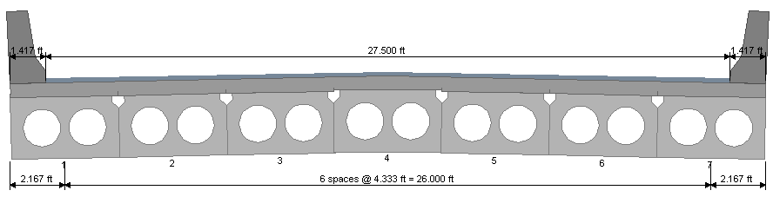

Suggestions
- Conduct a literature search for similar studies
- Deck modeling should include intermediate and end diaphragms
- Compare the load distribution to the lever rule of LRFD C4.6.2.2.1 and the load-on-pile approach of LRFD C4.6.2.2.2d

